* Stable / Unstable algorithms : concerned with how the algorithm treats equal (or repeated) elements Stable sorting algorithms preserve the relative order of equal elements, while unstable sorting algorithms don’t.

Stable sorting maintains the order of the two equal balls numbered 8, whereas unstable sorting may invert the relative order of the two 8s.

* Sorting algoritms – Трябва да елементите да са единтични и да могат се
сравняват, като за по сложните обекти трябва да използаме Comparable.
(Simple sorting algorithms Selection, Bubble, Insertion)
- Selection Sort: Swap the current element with the next lowest number.
Memory - (01)- (не създава допълнителни масиви), Stable- No, Method-Selection



public static void selectionSort(int[] arr){
for (int i = 0; i < arr.length - 1; i++)
{
int index = i;
for (int j = i + 1; j < arr.length; j++){
searching for lowest index
if (arr[j] < arr[index]){
index = j;
}
}
swap elements
int smallerNumber = arr[index];
arr[index] = arr[i];
arr[i] = smallerNumber;
}

- Bubble Sort: In bubble sort algorithm, array is traversed from first element to last
element. Here, current element is compared with the next element. If current element is
greater than the next element, it is swapped.

static void bubbleSort(int[] arr) {
int n = arr.length;
int temp = 0;
for(int i=0; i < n; i++){
Проверката на втория цикъм ни е такава защото сме си гарантирали
,че най големият елемент вече че е записан в края
for(int j=0; (j < n – i- 1); j++){
swap elements
if(arr[j] < arr[j + 1]){
temp = arr[j];
arr[j] = arr[j + 1];
arr[j + 1] = temp;
}

}

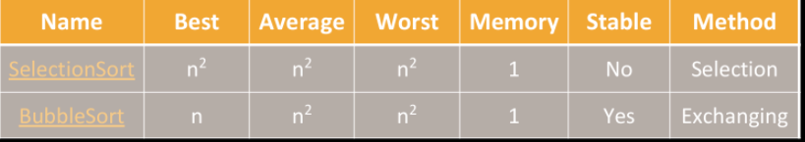
Insertion sort: Move the first unsorted element left to its place

* Function to sort an array using insertion sort*/
void insertionSort(int arr[], int n)
{
int i, key, j;
for (i = 1; i < n; i++)
{
key = arr[i];
j = i - 1;

/* Move elements of arr[0..i-1], that are
greater than key, to one position ahead
of their current position */
while (j >= 0 && arr[j] > key)
{
arr[j + 1] = arr[j];
j = j - 1;
}
arr[j + 1] = key;
}
}

(Advance sorting algorithms Quick Sort, Merge Sort, Bucked Sort)

*Merge Sort: Recursive algorithm.
1) Divide the list into sub-lists (typically 2 sub-lists)
2)Sort each sub-list (recursively call merge-sort)
3)Merge the sorted sub-lists into a single list

*Quick Sort: Choose a pivot; move smaller elements left & larger right; sort left &
right
